Name: Anika Jallipalli   
Date: 4/5/2020

**16.06 Picture Lab Worksheet**

**Directions**: Make note of your responses to the following questions as you work through the activities and exercise in the lesson.

**Activity 8 Exercise Results**

1. Paste the image that is the result of calling the second copy method that adds parameters to allow you to copy just part of the fromPic.

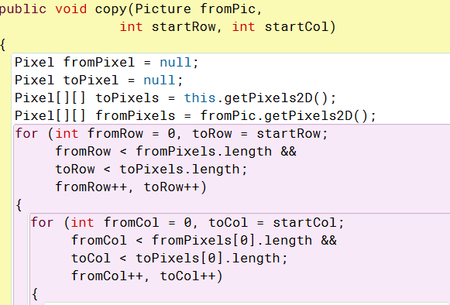

1. Paste the image that is the result of calling the myCollage method.

Sorry for the pictures being blurry in the command module they were small so when zoomed in it became blurry.

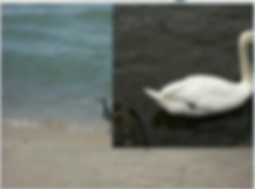

**Activity 9 Exercise Results**

1. Paste the image that is the result of calling the edgeDetection2 method.

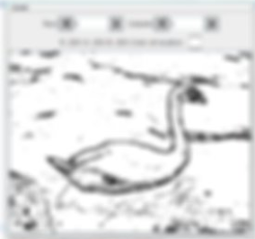

1. Think about and propose another algorithm for edge detection.

Instead of looking at a single pixel of the picture, look at the pictures around it to determine if that pixel is an edge piece. Instead of looking at color distance from the center pixel to the other pixels look at the other patterns of all the pixels around the center pixel. Edge pixels tend to be grouped with other edge pixels so it would be easy to know if an edge pixel is an edge pixel by observing the pixels around the center pixel.